Chapter 6

- Entity-Relationship(E-R) Data Model: it is a data model that facilitates the database design by allowing specification of a schema that represents the overall logical structure of the database.
- The E-R Model has three main concepts
  - entity sets:
entity: is a thing in the real world for example a person is an entity, a course, or a building.
Entity sets is a set of entities of the same type that share the same properties.
Extension of an entity set: is the real representaion of the entity set for example the extension of instructors in ain shams university database is an extension of the entity set instructors.

  - Attribute sets:
Attributes: are descriptive properties possessed by each member of an entity sets
attributes could be name, id, or age for student entity set
Entity Set
Attribute set
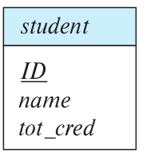

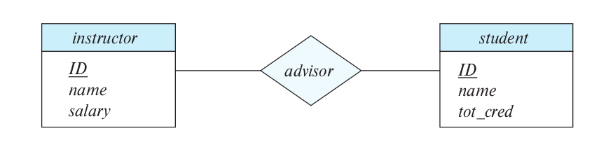
  - Relationship sets:
A relationship is an association among several entities. For example, we can deﬁne a relationship advisor that associates instructor Katz with student Shankar.
A relationship set is a set of relationships of the same type.
Relationship set
Entity set
Entity set

An entity set participates in a relationship set.
An entity role is the function that it playes in the relation ship set.

A relationship may also have attributes called descriptive attributes

Descriptive attribute

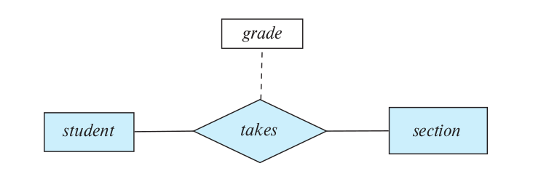

- the Domain or Value set of an attribute is the set of permitted value.
- There are different types of attributes
  - an attribute could be simple or composite
  - it could be single-valued or multivalued
  - Derived attributes

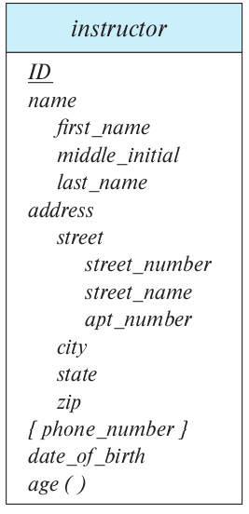
Composite attr.

multivalued
derived

- Mapping Cardinality: expresses the number of entities to which another entitiy can be associated via a relationship set.
  - One-to-one
  - One-to-Many
  - Many-to-One
  - Many-to-Many
- The relationship set is said to be total if every entity in a participated entity sets must participate in atleast one relationship, orelse it is said to be Partial, to indicate that a relationship is total the line to the entity set is drawn as two lines in the E-R diagram.

- Weak entity set: is an entity set whose existant is dependant on another entity set called Identifying entity set, then the primary key of the weak entity set is the primary key of the Identifying entity set along side with extra attribute called discriminator attribute,
the weak entity set is always total and many to one toward the identifying entity set
- Converting the E-R model into relational model
- the strong entity set with simple attributes is converted directly into schema.
- When the strong entity set contains some complex attributes
  - the composite attribute is handled such that, every component attribute is modeled in the relational model as single separate attribute and the composite attribute is ignored.
  - Multivalued attributes are modeled as separate relation with attributes that model the main multivalued attribute, and attributes that model the primary key of the entity set.

  - the derived attributes are not modeled in the relational model, they can be stored as functions or procedures in other data models
- we model the weak entity set by a relation with all the attributes of this weak entity set plus the primary key of the dependant strong entity set,
and the primary key of this relation is the primary key of the strong entity set plus the discriminator attributes of the weak entity set.
- We model the relationship set by a relation that has the primary keys of the participating entity set plus any discriptive attributes of the relationship set as attributes for that relation.
- If the participation of an entity set in a relation set is total and it is of “one” type(many-to-one) then both modeled relations are combined together, that is the relation for the relation set and the relation for the entity set.
- If the participation is partial and we want to combine anyways then we have to allow null values.
- Extended E-R diagram
- an entity set could have a subgroup of entities that shares some special attributes that the rest of the entitie doesn’t have for example person→employee,
this subgrouping is named Specialization
- we can depict the specialization in the E-R diagram as hollow arrow from the specialized to the general(like inheritance in UML)
- when we allow an entity to be in more than one specialization then it is an overlapping specialization else it is disjoint specialization
in overlapping specialization we draw two separate arrows, in disjoint we draw one arrow.
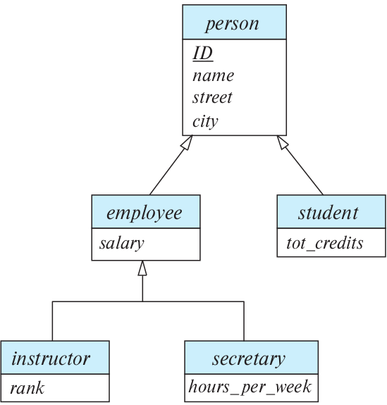

overlapping
disjoint

- If the superclass participate in a relationship set then all of its subclasses participate in the same relationship set implicitly
- Constraints on Specialization
  - overlapping or disjoint constraint
  - Completness constraint
    - Total Completness constraint: every entity in the high-lever entity set must belong to a lower level entity set
    - Partial Completness constraint: entities in the superclass my not be part of the subclasses
- Agrregation: we can treat relationship set as higher level entity set that can participate in other relationship set
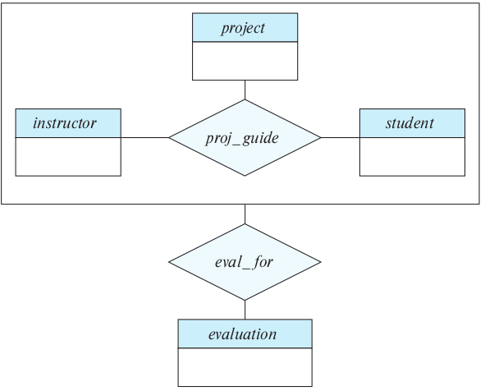

- Relational diagram modelling of the extended E-R Model
  - Modeling Generalization
    - create a schema for the higher level entity set
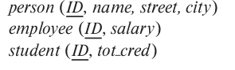
    - create a schema for the lower level entity set and add attributes that corresponds to the higher level entity set’s primary key, and these attributes become also the low level relations primary key with forign key constraint to the higher leve one

